**FATONI TRAVEL LIMITED PARTNERSHIP WEBSITE**

**HAJJ AND UMRAH WEBSITE FOR THAI PILGRIMS**

**ABDULHADI SASOR**

**621431017**

**MUHAMMAD BINHAJIMASMAN**

**621431008**

**THEIS SI COOPERATIVE EDUCATION PROJECT REPORT IS PART OF THE BACHELOR’S DEGREE PROGRAM.**

**REPORT FOR GATHERING REQUIREMENTS AND ANALYSIS, AND MAKING THE PROCESS OF REVERSE ENGINEERING, DATIL AND SPECIFICATION OF HAJJ AND UMRAH SERVICES WEBSITE APPLICATION.**

**BECHELOR OF SCINCE INFORMATION TECHNOLOGY, FACULTY OF SCINCE AND TECHNOLOGY OF FATONI UNIVERSITY**

**1444/2023**

**Title**: Fatoni Travel Limited

**Author**: MUHAMMAD BIN HAJMASAMAN 621431008.

ABDULHADI SASOR 621431017.

**Department:** INFORMATION TECHNOLOGY.

**Academic year:** 2023.

**Advisor:** MR.FAUZAN MAPA

# ABSTRACT

Fatoni University has approved the students to work for cooperative. Between 13 Dec 2022 till 10 Mar 2023, in the position of cooperative education student at Fatoni Travel Limited Partnership, the company’s main service is made booking travels for Hajj & Umrah and collecting information from the travelers who want to do Hajj & Umrah adding Date and Plans when to have flight where to stay in Makkah or Madinah with Tokseh who has more than 30 years of experience living in Kingdom of Saudi Arabia for responsibility for the travelers booked with the company. The company assigned for website to preview packages and information and some details about the services to contact more easily with employees

# ACKNOWLEDGMENT

We glad to have the opportunity to work in cooperative Fatoni Travel Limited Partnership since 13 Dec 2022 till 10 Mar 2023 was accomplished, our appreciation and gratitude to the kindness of consultants and employees. Other people in the workplace and outside the workplace educative as well as valuable advice to bring applied to make reports and develop the website it also provides suggestions and guidelines for conducting reports.

Entrepreneurship working with others including gaining various experiences in addition to studying by this work would not have been possible without the personnel within Fatoni Travel Limited Partnership to provide advice, as well as providing new knowledge on working and adapting to the environment of workplace within the organization appropriately, which has received cooperation and support from various personnel in the organization as follows:

- MR. MAHAMMASHUKRI YISAMA-AE Administrator

- MRS. SITI FATIMOH AMAE Hajj Officer

- MRS. NUBSOH KAEWSAM Hajj officer

Including all other people not mentioned by name who gave advice and assistance in preparing the report. We would like to thank Fatoni Travel Limited Partnership for the support and accepting cooperative education students. Finally, if any mistakes occur the organizer would like to accept it and sincerely apologize on this occasion and the organizers sincerely hope that this Website report will be useful to who are interested.

# TABLE OF CONTEN

Contents

ABSTRACT II

ACKNOWLEDGMENT III

TABLE OF CONTEN IV

CHAPTER 1 INTRODUCTION 1

1.1 Objective 1

1.2 Company history and details 1

1.3 Assigned responsibility 2

1.4 Advisor staff 2

1.5 Working duration 2

1.1 PROJECT OVERVIEW 2

1.2 PROBLEM STATEMENT 3

OBJECTIVE 3

1.4 PROJECT SCOPE 4

1.5 PROJECT SIGNIFICANT 4

1.5.1 User 4

1.5.2 Developer 4

1.6 HARDWARE AND SOFTWARE 4

1.6.1 Software requirements 4

1.6.2 Hardware requirement 5

CHAPTER 2 WORK PROCESS DTAILS 6

2.1 WORK SCHEDULE 6

Figure 2.1: Table Work schedule 6

2.2 Cooperative Education project details 7

Figure 2.3: Agile Representation 9

2.2.5 Phases of Agile Model: 9

PHP 9

MYSQL DATABASE 10

XAMPP 10

LARAVEL 10

CSS 11

VIRTUAL STUDIO CODE 11

JAVASCRIPT 12

MYSQL WORKBENCH 12

SOURCE CONTROL(GITHUB) 12

2.3 PROJECT INTERFACE 14

2.3 PROJECT DIAGRAMS 18

2.4 SPROJECT RESULT 23

CHAPTER 3 24

PERFORMANCE SUMMARY 24

3.1 EXPECTATION OF COOPERATIVE EDUCATION PRACTICE 24

3.2 BENEFITS FROM COOPERATIVE EDUCATION PRACTICE 24

3.2.1 Benefits of own self 24

3.2.2 Benefits for the organization 24

3.2.3 Benefits for the university 24

3.3 ANALYZE STRENGTHS AND WEAKNESSES OPPORTUNITIES AND OBSTACALES 25

3.4 Impressive experience / special experience 26

References 27

SEQUENCE DIAGRM 29

FTLP Register Sequence 29

FTLP Login sequence 30

FTLP Package Sequence 31

ACTIVITY DIAGRAM 32

FTLP Registration Activity 32

Logging Activity 33

FTLP Login Activity 33

FTLP Package page Activity 34

Appendix B 34

Project codes 43

suggestions for system improvement 47

# CHAPTER 1 INTRODUCTION

Co-operative education is an educational system that emphasizes systematic operations in the workplace. by providing study on-campus instruction combined with social practice and gain hands-on experience.

Operate as an employee It is a system that combines Learn with real practice (Work integrated Learning: WIL) contributes to the development of various skills for students to be able to do real work. as an employee It gives students an experience that cannot be found in the classroom. It is also a promotion analytical thinking process, decision-making with events encountered and practicing observation It is therefore a good opportunity for students to discover the true potential and needs of More clear career tasks, performance objectives

## Objective

1. To give students the opportunity to learn, develop skills and gain real working life experience in order to get ready before going off to work.
2. To be able to work under the pressure of workplace.
3. Preparing for workplace environment and employee mentality.
4. The ability to implement any of the requirements in a timely manner.

## 1.2 Company history and details

Location: ISLAMIC SYSTEMS CORPARATION CO, LTD

Address 1332 Asidik Islamic Cooperative Building, 3rd floor

Petchkasem Road, hat Yai Subdistrict, Hat Yai District, Songkhla Province 90110

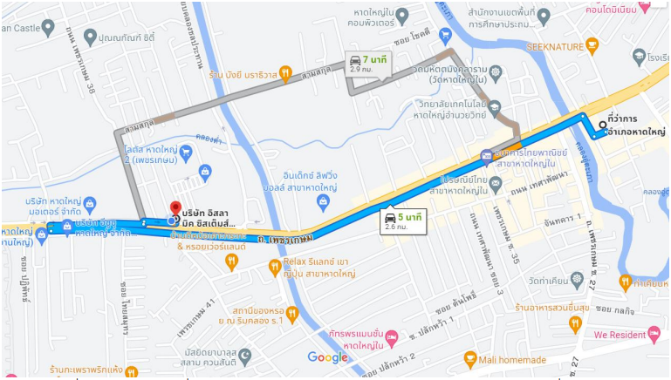Map:

##### Figure 1: Route from Hat Yat District Office to Islamic Systems

## Assigned responsibility

Position: Programmer (Front-End), Designer.

Assigned tasks: Develop the company booking website.

## 1.4 Advisor staff

MR. MAHAMMASHUKRI YISAMA-AE Administrator

## 1.5 Working duration

Cooperative Education Practice for the 1st Semester of the Academic Year 2022 Duration from December 13, 2022 to March 10, 2023, a total of 13 weeks.

## 1.1 PROJECT OVERVIEW

Hajj and Umrah are two of the main aspects of Islam. Hajj is the last pillar of Islam's 5 pillars, and Muslims are required to do it if they have the ability to do. but at the other hand, Umrah is a lesser form of Hajj that consists of tasks that take place only at Masjid AL-Haram and can be finished in one day. The developed website made to help make the possibility of Hajj and Umrah easier to achieve, Hajj and Umrah contains sequences of steps and progressions, progressing from Mina to Arafat, staying in Muzdalifah collecting pebbles, returning to Mina to throw small stones at Jamarat, and farewell Tawaf.

Before performing Hajj and Umrah, there is processes, such as booking airlines, determining when and where the pilgrim should depart and land, and, due to cultural differences between Thailand and Saudi Arabia. All of these sequences of steps must be monitored and solved, and must be made and processed in a timely manner.

In this era of technology, there is a lot of development and expansion for the better, which means there are a lot of changes that need to be made. The traditional way of processing pilgrim data and information, which uses paper, is a thing of the past; we need new ways to complete our tasks, and we need to use technology to complete the pilgrim's ritual.

## 1.2 PROBLEM STATEMENT

As any pilgrim anywhere in the world knows, the process of Hajj and Umrah is fraught with problems, such as booking flights, calculating out where to start and when to begin, and need guidelines and instructional tools for pilgrims to follow in order to avoid getting lost, keeping track of time and specific dates related to Hajj and Umrah, and keeping on top about your own pilgrim’s society, and that is why Islam accepts and forgives those who are unable to perform it (citation). The issues here in Thailand include that there is no website or app that makes the Hajj and Umrah process, as well as any problems or difficulties that may arise.

## OBJECTIVE

This project is to make somethings more convenient:

* To analyze and design Fatoni travel limited partnership for Hajj and Umrah web application
* To develop Fatoni travel limited partnership for Hajj and Umrah web application
* To develop Packages and plans preview platform within Fatoni travel limited partnership for Hajj and Umrah web application

## 1.4 PROJECT SCOPE

This project will develop as Web website and has Three languages such as (English, Thai) for that point it will present to Crew (Tokseh), Staff (agent, employee) that work in company. Application will preview Packages that allow pilgrims to Hajj and Umrah The project targeting the crews (Tokseh)who can reach people want to do Hajj and Umrah. making platform that can have contact between Saudi Arabia and Thailand to made Fatoni travel limited partnership for the pilgrims. Allowing crews and Mutawif (Leader of providing Hajj and Umrah in Saudi Arabia) to have information about pilgrims. Make platforms for pilgrims who visit the website to preview the information about hajj.

## 1.5 PROJECT SIGNIFICANT

### 1.5.1 User

* Save time and make booking much easier process, the user only needs to input email and some needed data.
* Can see the available plans and chooses what suits the users.
* Can see the transportation or hotels available in the 2 holy places Makkah and Madinah.
* Easier way to input information needed, the server will for sure save information received from the user.
* Ability to have connection with the staff they can help the pilgrims.

### 1.5.2 Developer

* Improve skill
* Improvement of web development skill which consist of back-end front end, and web developments platforms, and be more capable in solving web development problems
* Learn new things The developer will increase more web development knowledge hopefully and intermediate full stack developer.

## 1.6 HARDWARE AND SOFTWARE

## 1.6.1 Software requirements

|  |  |
| --- | --- |
| **Software** | **Version** |
| Xampp |  |
| PHP | 7.2.5 | 8.0 |
| MySQL | 10.1.37 |
| JavaScript |  |
| Bootstrap | 4.6.0 |
| Git | 2.32.0 |
| Laravel | 6.20 |
| VS code | 1.60.2 |
| Adobe XD |  |

|  |  |
| --- | --- |
| **Specification** | Asus Tuff |
| **OS** | Windows 10 |
| **CPU** | AMD Ryzen 5 3550H with Radeon Vega Mobile Gfx 2.10 GHz |
| **Display** | (1920 x 1080) AMD Radon  Vega 8 graphics |
| **Memory** | 16.0 GB 2400MHz DDR2 |
| **Storage** | HDD Toshiba 1 Tera  SSD Samsung 239 GB |
| **Network interface** | Realtek 8822BE Wireless LAN 802.11ac PCI-E NIC  Bluetooth 10.0 personal area network |

## 1.6.2 Hardware requirement

# CHAPTER 2 WORK PROCESS DTAILS

## 2.1 WORK SCHEDULE

Cooperative education practice at the Islamic System Corporation, starting from the 13 December 2022 Cooperative Education ended on 10 March 2023 for a period of 13 weeks, which received assign tasks as shown in table, Cooperative Education Action plan.

|  |  |  |  |  |  |  |  |  |
| --- | --- | --- | --- | --- | --- | --- | --- | --- |
| **No** | **Tasks/**  **Dates** | **December** | | | **January** | | | |
| 12 to 16 | 19 to 23 | 26 to 30 | 2 to 6 | 9 to 13 | 16 to 20 | 23 to 27 |
| 1 | Home page |  |  |  |  |  |  |  |
|  |  |  |  |  |  |  |
| 2 | Login page |  |  |  |  |  |  |  |
| 3 | Register page |  |  |  |  |  |  |  |
| 4 | Services |  |  |  |  |  |  |  |
| 5 | Admin page |  |  |  |  |  |  |  |
| 6 | Dashboard |  |  |  |  |  |  |  |

|  |  |  |  |  |  |  |  |
| --- | --- | --- | --- | --- | --- | --- | --- |
| **No** | **Tasks/**  **Dates** | **February** | | | | **March** | |
| 30 to 3 | 6 to 10 | 13 to 17 | 20 to 24 | 27 to 3 | 6 to 10 |
| 7 | Building tables in Database |  |  |  |  |  |  |
| 8 | Hajj/Umrah Packages |  |  |  |  |  |  |
| 9 | Photo edit preview |  |  |  |  |  |  |
| 10 | Present progress |  |  |  |  |  |  |
| 11 | Re design all pages |  |  |  |  |  |
| 12 | Writing Project proposal |  |  |  |  |  |  |
| 13 | Editing information in project |  |  |  |  |  |  |

### Figure 2.1: Table Work schedule

## 2.2 Cooperative Education project details

#### 2.2.1 Project overview

Hajj and Umrah are two of the main aspects of Islam. Hajj is the last pillar of Islam's 5 pillars, and Muslims are required to do it if they have the ability to do. but at the other hand, Umrah is a lesser form of Hajj that consists of tasks that take place only at Masjid AL-Haram and can be finished in one day. The developed website made to help make the possibility of Hajj and Umrah easier to achieve, Hajj and Umrah contains sequences of steps and progressions, progressing from Mina to Arafat, staying in Muzdalifah collecting pebbles, returning to Mina to throw small stones at Jamarat, and farewell Tawaf (al-Modarresi, 2016).

Before performing Hajj and Umrah, there is processes, such as booking airlines, determining when and where the pilgrim should depart and land, and, due to cultural differences between Thailand and Saudi Arabia. All of these sequences of steps must be monitored and solved, and must be made and processed in a timely manner.

In this era of technology, there is a lot of development and expansion for the better, which means there are a lot of changes that need to be made. The traditional way of processing pilgrim data and information, which uses paper, is a thing of the past; we need new ways to complete our tasks, and we need to use technology to complete the pilgrim's ritual (Mohamed, 2009).

#### 2.2.2 SOFTWARE DEVELOPMENT LIFE CYCLE

The Software Development Life Cycle (SDLC) is the software development worlds spellcheck it can flag errors in software creation before they’re discovered (at a much higher cost) in successive stages. But it’s much more than that, of course: SDLC can also lay out a plan for getting everything right the first time.

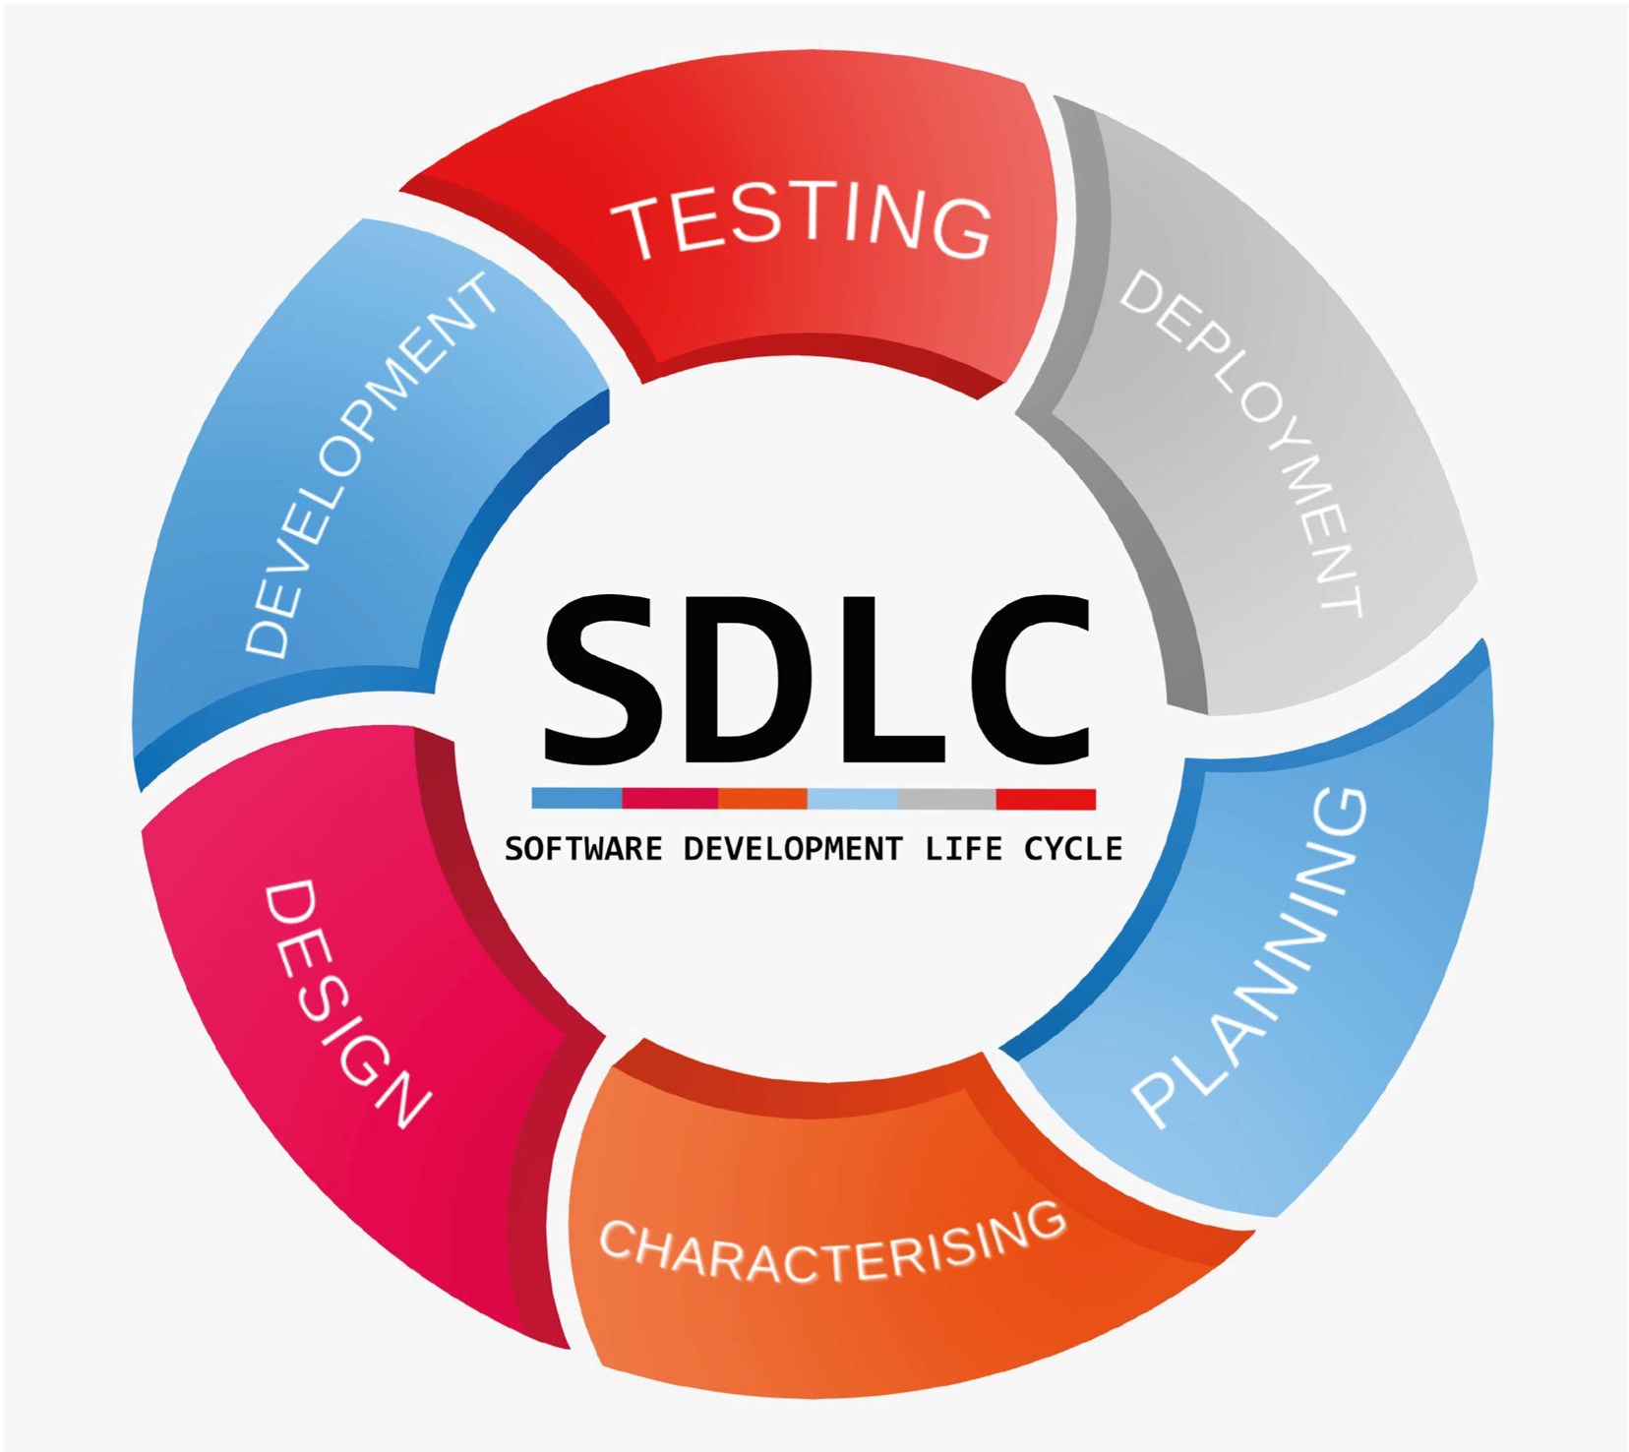The SDLC process involves several distinct stages, including planning, analysis, design, building, testing, deployment and maintenance. What’s the best SDLC methodology? Here are six methodologies, or models, to consider (Taylor, 2004).

##### Figure 2.2: SDLC Representation

#### 2.2.3 SDLC Phases:

1. Planning
2. Analysis
3. Design
4. Implementation
5. Testing and Integration
6. Maintenance

### What is Agile development?Figure 2.3: Agile Representation

#### 2.2.4 Agile

The meaning of Agile is swift or versatile. “Agile process model" refers to a software development approach based on iterative development. Agile methods break tasks into smaller iterations, or parts do not directly involve long term planning. The project scope and requirements are laid down at the beginning of the development process. Plans regarding the number of iterations, the duration and the scope of each iteration are clearly defined in advance (Rally, 2016).

### 2.2.5 Phases of Agile Model:

Following are the phases in the Agile model are as follows:

1. Requirements gathering
2. Design the requirements
3. Construction/ iteration
4. Testing/ Quality assurance
5. Deployment
6. Feedback

#### 2.2.6 Used tools

### PHP

Stands for "Hypertext Preprocessor." (It is a recursive acronym, if you can understand what that means.) PHP is an HTML-embedded Web scripting language. This means PHP code can be inserted into the HTML of a Web page. When a PHP page is accessed, the PHP code is read or "parsed" by the server the page resides on. The output from the PHP functions on the page are typically returned as HTML code, which can be read by the browser. Because the PHP code is transformed into HTML before the page is loaded, users cannot view the PHP code on a page. This makes PHP pages secure enough to access databases and other secure information. A lot of the syntax of PHP is borrowed from other languages such as C, Java and Perl. However, PHP has a number of unique features and specific functions as well. The goal of the language is to allow Web developers to write dynamically generated pages quickly and easily. PHP is also great for creating database-driven Web sites. (Techterms,2020)

### MYSQL DATABASE

A MYSQL Database is a relational database that uses MySQL language to get the data. MYSQL database contains the data in table and relation between tables such as one to one (one data has refer one data in another table), one to many (one data has refer to many data in others table) (Christensson, 2009).

### XAMPP

XAMPP is an abbreviation for cross-platform, Apache, MySQL, PHP and Perl, and it allows you to build WordPress site offline, on a local web server on your computer. This simple and lightweight solution works on Windows, Linux, and Mac – hence the “cross-platform” part. Since WordPress isn’t a stand-alone application, XAMPP provides two essential components for its installation – Apache, which is used to create the local server, and MySQL which you can use as a database for your website. You may be wondering why and how developers are using WordPress local server. The answer is simple – it allows them to create a local copy of the site in which they can try out new plugin updates before implementing them on its live version (Apachefriends, 2015).

### LARAVEL

Laravel is a web application framework with expressive, elegant syntax We believe development must be an enjoyable, creative experience to be truly fulfilling Laravel attempts to take the pain out of development by easing common tasks used in the majority of web projects, such as authentication, routing, sessions, and caching. Laravel aims to make the development process a pleasing one for the developer without sacrificing application functionality Happy developers make the best code (Laravel, 2014). To this end, we've attempted to combine the very best of what we have seen in other web frameworks, including frameworks implemented in other languages, such as Ruby on Rails, ASP NET MVC, and Sinatra. Laravel is accessible, yet powerful, providing powerful tools needed for large, robust applications. A superb inversion of control container, expressive migration system, and tightly integrated unit testing support give you the tools you need to build any application with which you are tasked (Luravel, 2019).

### CSS

Stands for "Cascading Style Sheet." Cascading style sheets are used to format the layout of Web pages They can be used to define text styles, table sizes, and other aspects of Web pages that previously could only be defined in a page's HTMI, CSS helps Web developers create a uniform look across several pages of a Web site. Instead of defining the style of each table and cache block of text within a page's HTML, commonly used styles need to be defined only once in a CSS document. Once the style is defined in a cascading style sheet, it can be used by any page that references the CSS file Plus, CSS makes it easy to change styles across several pages at once for example, a Web developer may want to increase the default text size from 10pt to 12pt for fifty pages of a Web site. If the pages all reference the same style sheet, the text size only needs to be changed on the style sheet and all the pages will show the larger text. While CSS is great for creating text styles, it is helpful for formatting other aspects of Web page layout as well. For example, CSS can be used to define the cell padding of table cells, the style, thickness, and color of a table's border, and the padding around images or other objects. CSS gives Web developers more exact control over how Web pages will look than HTML does. This is why most Web pages today incorporate cascading style sheets (Christensson, 2009).

### VIRTUAL STUDIO CODE

Visual Studio Code is a code editor redefined and optimized for building and debugging modern web and cloud applications. (Shukerullah,2018) Visual Studio Code is a cross-platform, free and open-source (licensed under the MIT License) text editor developed by Microsoft and written in JavaScript and TypeScript. It is built on the Electron framework and is extensible using extensions, which can be browsed from within the text editor itself (via its extension gallery) (Archlinux, 2018) (Lardinois, 2018).

### JAVASCRIPT

JavaScript is a programming language commonly used in web development. It was originally developed by Netscape as a means to add dynamic and interactive elements to websites. While JavaScript is influenced by Java, the syntax is more similar to C and is based on ECMAScript, a scripting language developed by Sun Microsystems. JavaScript is a chent-side scripting language, which means the source code is processed by the client's web browser rather than on the web server This means JavaScript functions can run after a web page has loaded without communicating with the server For example, a JavaScript function may check a web form before it submitted to make sure all the required fields have been filled out The JavaScript code can produce an error message before any information is actually transmitted to the server Like server-side scripting languages, such as PHP and ASP, JavaScript code can be inserted anywhere within the HTML of a webpage (ECMAScript, 2020). However, only the output of server-side code is displayed in the HTML, while JavaScript code remains fully visible in the source of the webpage. It can also be referenced in a separate JS file, which may also be viewed in a browser (Christensson, 2009).

### MYSQL WORKBENCH

MYSQL Workbench is a unified visual tool for database architects, developers, and DBAS. MYSQL Workbench provides data modeling, SQL development, and comprehensive administration tools for server configuration, user administration, backup, and much more. MYSQL Workbench is available on Windows, Linux and Mac OS X (mysql, 2019).

### SOURCE CONTROL(GITHUB)

Source control (or version control) is the practice of tracking and managing changes to code. Source control management (SCM) systems provide a running history of code development and help to resolve conflicts when merging contributions from multiple sources. (Amazon, 2019) GitHub is a for-profit company that offers cloud-based Git repository hosting service. Essentially, it makes it a lot easier for individuals and teams to use Git for version control and collaboration (Kinsta, 2019).

#### 2.2.7 Operation steps

1. Study and understand the requirements received.
2. Plan the work that needs to be achieved and schedule it.
3. Design the system according to the assigned design
4. Fix bugs and solve problem after getting feedback
5. Improve the system and look for new feature if there’s capability

## 2.3 PROJECT INTERFACE

Login page

##### Figure 2.4: Fatoni Travel website login page

##### 

Register page

Can create new user

##### Figure 2.5: Fatoni Travel website

##### Figure 2.6: Fatoni Travel website Admin dashboard

Tables so admin can edit or delete

Home page dashboard

##### 

Add new package

Tables so admin can edit or delete

Delete button

Edit button

##### Figure 2.7 Fatoni Travel website packages details

##### Figure 2.8: Fatoni Travel packages page

Home page

For more details about packages

Packages form in package pages

Packages form in home pages

Information can display in this form

##### Figure 2.9: Fatoni Travel Website home page

##### Figure 2.10: Package detail

Click on the categories to see the details

Hotel’s location

The flight Airline detail

Days & price

Package name

Click to see details of package

##### Figure 2.11: Fatoni Travel Policy details

## 2.3 PROJECT DIAGRAMS

#### 2.3.1 Design of material system

### 

##### Figure 2.12: Data flow diagram

#### 2.3.2 Use case diagram

##### Figure 2.13: Use case diagram

#### 2.4.3 List of requirements

|  |  |  |  |
| --- | --- | --- | --- |
| **No.** | **Req _ ID** | **Requirement Description** | **Priority** |
|  | Req_01 | Sign in |  |
| 1 | Req_1.1 | Administrator can sign in | M |
| 2 | Req_1.2 | Crew (Tokseh) can sign in | M |
| 3 | Req_1.3 | User (Pilgrim) can sign in | O |
|  | Req_2 | Manage Packages |  |
| 4 | Req_2.1 | Admin can add packages | M |
| 5 | Req_2.2 | Admin can update packages | M |
| 6 | Req_2.3 | Admin can delete packages | M |
| 7 | Req_2.4 | Admin can view packages | M |
| 8 | Req_2.5 | Crew (Tokseh) choose suitable plans for their package | M |
| 9 | Req_3.6 | Crew (Tokseh) can contact with the provider of available flights | D |
| 10 | Req_3.7 | Crew (Tokseh) can contact with the provider of available hotels | D |
| 11 | Req_3.8 | Crew (Tokseh) choose suitable plans for their package | M |
|  | Req_3 | Manage package research |  |
| 8 | Req_3.1 | Admin can add package research |  |
| 9 | Req_3.2 | Admin can update package research |  |
| 10 | Req_3.3 | Admin can delete package research |  |
| 11 | Req_3.4 | Admin can view package research |  |
| 12 | Req_3.5 | Admin can search package research |  |
|  | Req_2.1 | Admin Provide platform that recommends where to get flights plans | M |
|  | Req_2.2 | Admin Provide platform that recommends where to get hotels | M |
|  | Req_2.3 | Crew (Tokseh) can add his own flights plan from his own research, not provided by the admin | M |
|  | Req_2.4 | Crew (Tokseh) can add his own hotels plan from his own research, not provided by the admin | M |
|  | Req_4 | Manage preview package |  |
| 13 | Req_4.1 | Admin can create preview package | M |
| 14 | Req_4.2 | Admin can update preview package | M |
| 15 | Req_4.3 | Admin can delete preview package | M |
| 16 | Req_4.4 | Admin can view preview package | M |
| 17 | Req_4.5 | Crew can create preview package | M |
| 18 | Req_4.6 | Crew can update preview package | M |
| 19 | Req_4.7 | Crew can delete preview package | M |
| 20 | Req_4.8 | Crew can view preview package | M |
| 21 | Req_4.9 | User (Pilgrim) can add suitable package for them | M |
| 22 | Req_4.10 | User(pilgrim) can look up for specific hotel where it displays which Tokseh have it in their own plan or package | D |
| 23 | Req_4.11 | User(pilgrim) can look up for specific flights where it displays which Tokseh have it in their own plan or package | D |
| 24 | Req_4.12 | User(pilgrim) can create their own custom plan and recommend it to the Tokseh platform |  |
| 25 | Req_4.13 | User can book package |  |
| 26 | Req_4.14 | User can update and change package |  |
| 27 | Req_4.15 | User can delete package |  |
|  | Req_5 | Manage pilgrim |  |
| 21 | Req_5.1 | Admin can add pilgrim | M |
| 22 | Req_5.2 | Admin can update pilgrim | M |
| 23 | Req_5.3 | Admin can delete pilgrim | M |
| 24 | Req_5.4 | Admin can view pilgrim | M |
| 25 | Req_5.5 | Crew can add pilgrim | M |
| 26 | Req_5.6 | Crew can update pilgrim | M |
| 27 | Req_5.7 | Crew can delete pilgrim | M |
| 28 | Req_5.8 | Crew can view pilgrim | M |
|  | Req_6 | Manage recommend pilgrims package |  |
| 29 | Req_6.1 | Admin can add command pilgrim |  |
| 30 | Req_6.2 | Admin can update command pilgrim |  |
| 31 | Req_6.3 | Admin can delete command pilgrim |  |
| 32 | Req_6.4 | Admin can view pilgrim |  |
| 33 | Req_6.5 | Crew can add command pilgrim |  |
| 34 | Req_6.6 | Crew can update command pilgrim |  |
| 35 | Req_6.7 | Crew can delete command pilgrim |  |
| 36 | Req_6.8 | Crew can view command pilgrim |  |
|  | Req_7 | View report |  |
| 37 | Req_7.1 | Admin can view report |  |
|  | Req_8 | Manage crew |  |
| 38 | Req_8.1 | Admin can add crew |  |
| 39 | Req_8.2 | Admin can update crew |  |
| 40 | Req_8.3 | Admin can delete crew |  |
| 41 | Req_8.4 | Admin can crew |  |
|  | Req_9 | Manage preview order |  |
| 42 | Req_9.1 | Admin can add order |  |
| 43 | Req_9.2 | Admin can update order |  |
| 44 | Req_9.3 | Admin can delete order |  |
| 45 | Req_9.4 | Admin can view order |  |
| 46 | Req_9.5 | (User)Pilgrim can add order |  |
| 47 | Req_9.6 | (User)pilgrim can update order |  |
| 48 | Req_9.7 | (User)Pilgrim can delete order |  |
| 49 | Req_9.8 | (User)pilgrim can view order |  |
|  | Req_10 | Manage pilgrims Stats |  |
| 50 | Req_10.1 | Admin can add pilgrims Stats |  |
| 51 | Req_10.2 | Admin can view pilgrims Stats |  |
| 52 | Req_10.3 | Admin can delete pilgrims Stats |  |
| 53 | Req_10.4 | Admin can update pilgrims Stats |  |
| 54 | Req_10.5 | Crew can add pilgrims Stats |  |
| 55 | Req_10.6 | Crew can view pilgrims Stats |  |
| 56 | Req_10.7 | Crew can delete pilgrims Stats |  |
| 57 | Req_10.8 | Crew can update pilgrims Stats |  |

## 2.4 SPROJECT RESULT

* Able to login as Admin, normal user and Tokseh and give different permission for each.
* Able to show and see the packages.
* Able to manage the numbers of users in the website for the admin.
* Able to see the details of the packages.

# CHAPTER 3

# PERFORMANCE SUMMARY

## 3.1 EXPECTATION OF COOPERATIVE EDUCATION PRACTICE

* Gaining the knowledge to develop better program and new program development models
* Gaining Experience of workplace environment and challenges
* Gaining the skill of teamwork and the pressure of the workplace and practice patience from various pressure and also teammates.

## 3.2 BENEFITS FROM COOPERATIVE EDUCATION PRACTICE

### 3.2.1 Benefits of own self

* Learned working experience by going to a real workplace environment
* Learn and develop new skills while working such as teamwork, and skills within the profession
* Responsibility of the assigned tasks
* Improve programming development skill such as planning the work, achieving the tasks, gathering requirements, gathering feedback, designing user interface, development of a user-friendly application.
* Gaining more opportunity for work hiring

### 3.2.2 Benefits for the organization

* Develop systems according to the organization needs and requirements
* Create cooperation and reputation between enterprises and educational institutions

### 3.2.3 Benefits for the university

* Create good reputation and image for the university
* Helping universities to be more recognized by enterprises in the labor market
* Collaboration and good relation with the organization

## 3.3 ANALYZE STRENGTHS AND WEAKNESSES OPPORTUNITIES AND OBSTACALES

**Highlight**

* Have determination, patience and determination to complete the tasks that they have been assigned to do well.
* able to study, learn, find information very well.
* Willingness to learn, and patience of the slowness in gaining knowledge.
* Determination to complete hardcore task that’s assigned.
* Fast researching and flash reading skill when researching about specific issue or problem for solving it and the skill of relating what’s been researched with the faced problem.

**Disadvantage**

* Language issues making difficulties to communicate with the employees.
* Lack of work from the department.
* Not having the passion to get more work and more assign from the department.
* Getting bored fast and always looking for something new or for a change of task and new ones even though the first assigned tasks were not finished yet.

**Advantage**

* Have a chance to make communication with people in Thai language.
* Chance to develop a real website that will be used in future and gain knowledge to how fix the problems.
* Work in real company and know how the work environment look like.

**Challenges**

* Communication with the staffs that doesn’t understand your language.
* Be able to do the requirement that been asked.
* Always adding up new requirement or edit it up after finishing one of them.

## 3.4 Impressive experience / special experience

Being in real work place is giving a different emotions and feelings as well as being assigned with a real task to build a website project and receiving the requirement from the manager is giving you a picture about how the real work will be like, this all teach you the patient and how to be strong and accept what the client try to tell you and understand them well.

Working in environment that full of energy and kindness help you and encourage you to work and do the best what you can do and don’t give up easily, this all to let you know that the life yes it hard but the life is beautiful also all what you need to do is change your perspective and change your mind.

# References

al-Modarresi, M. T. (2016). *The Laws of Islam.*

Apachefriends. (2015). New XAMPP with MariaDB. *Apachefriends*.

Archlinux. (2018).

Bukhari. (n.d.). In Bukhari, *Sahih Bukhari* (p. 4777).

Christensson. (2009).

*ECMAScript.* (2020). Retrieved from Language Specification: https://tc39.es/ecma262/#sec-overview

Kinsta. (2019).

Laravel. (2014, 8 30). *Laravel Documentation.* Retrieved from Laravel.com: https://laravel.com/docs/10.x

Lardinois, F. (2018, 4 15). *Microsoft Launches Visual Studio code.* Retrieved from A free cross-platforms conde editor for OS X: https://techcrunch.com/2015/04/29/microsoft-shocks-the-world-with-visual-studio-code-a-free-code-editor-for-os-x-linux-and-windows/

Luravel. (2019).

Mohamed, m. (2009). *Hajj to Umrah: from A to Z.* Amana.

mysql. (2019).

Rally. (2016). *Agile With a Capital "A" Vs. Agile With a Lowercase "a".*

Taylor, J. (2004). *Managing information Technology projects.*

**APPENDIX**

## SEQUENCE DIAGRM

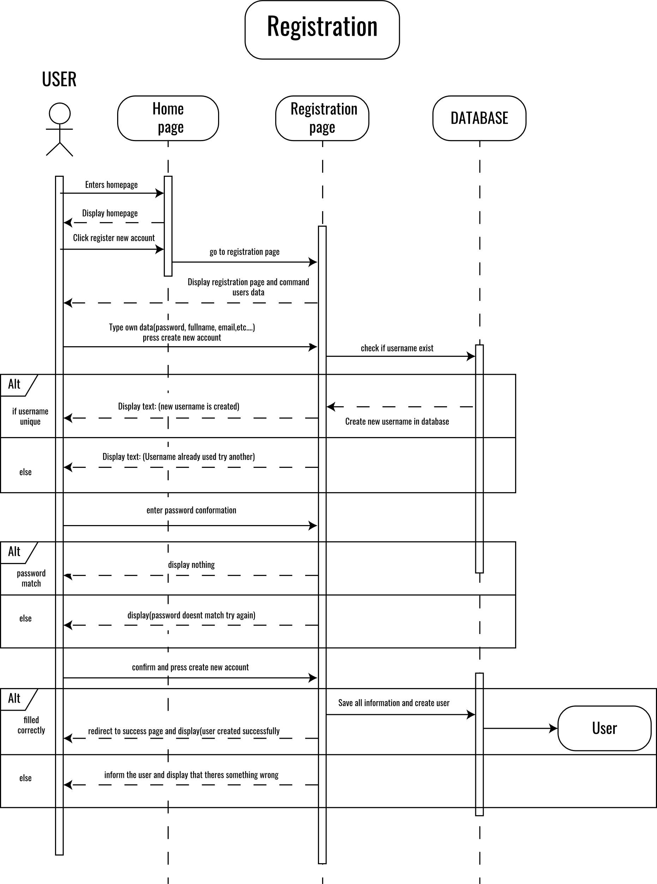Sequence diagram describes how groups of objects collaborate in some behavior. The UML defines several forms of interaction diagram. Developer use sequence diagrams when developer wants to look at the behavior of several objects within a single use

### FTLP Register Sequence

### FTLP Login sequence

### FTLP Package Sequence

## ACTIVITY DIAGRAM

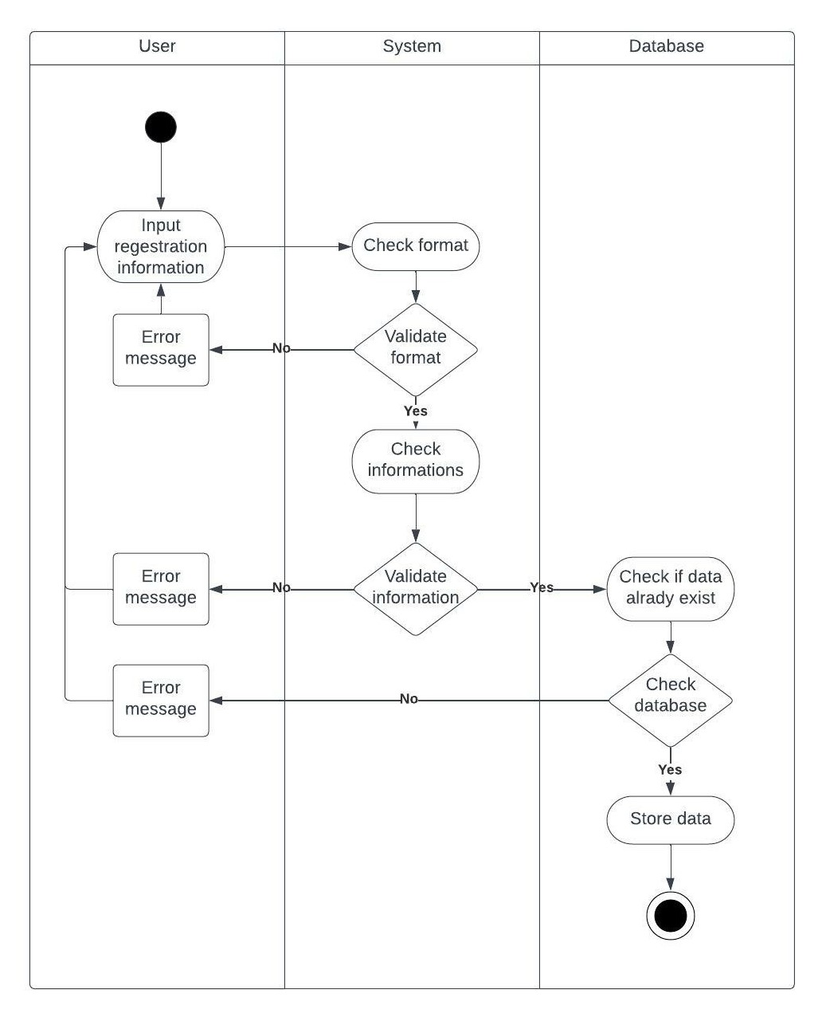Activity diagrams are a technique to describe procedural logic, business process, and work flow. In many ways, they play a role similar to flowcharts, but the principal difference between them and flowchart notation is that they support parallel behaviour. notation is that they support parallel behavior.

### FTLP Registration Activity

## Logging Activity

### FTLP Login Activity

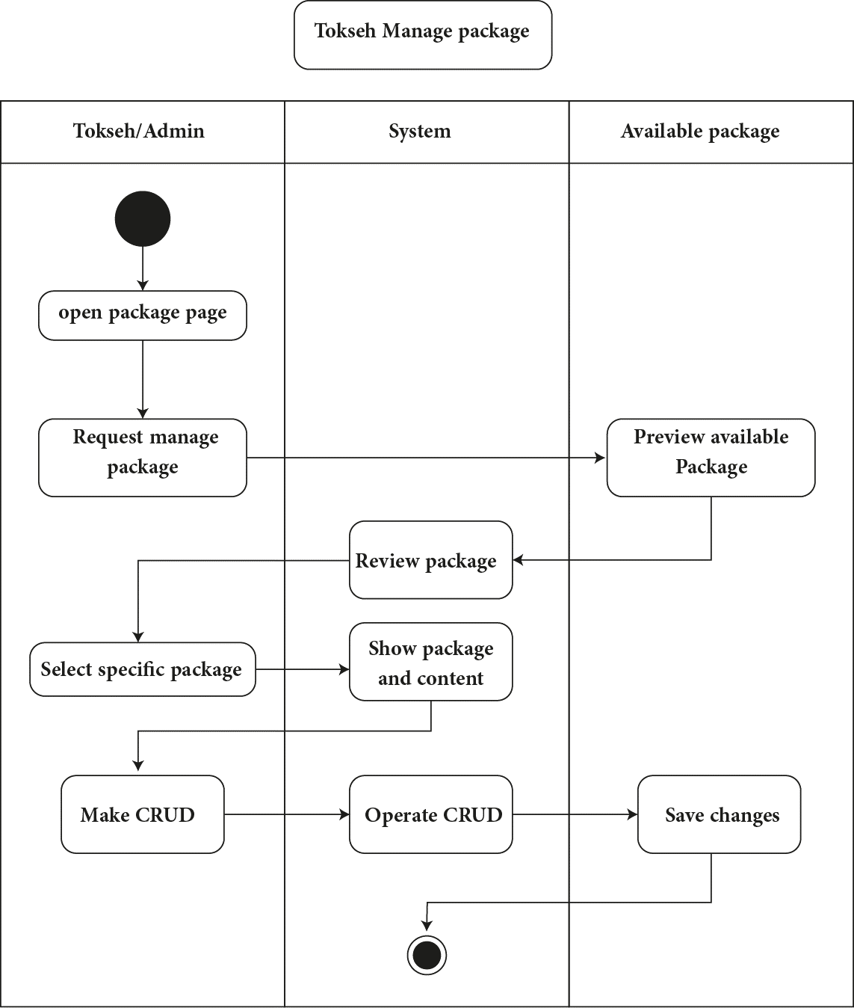

### FTLP Package page Activity

## Appendix B

1. 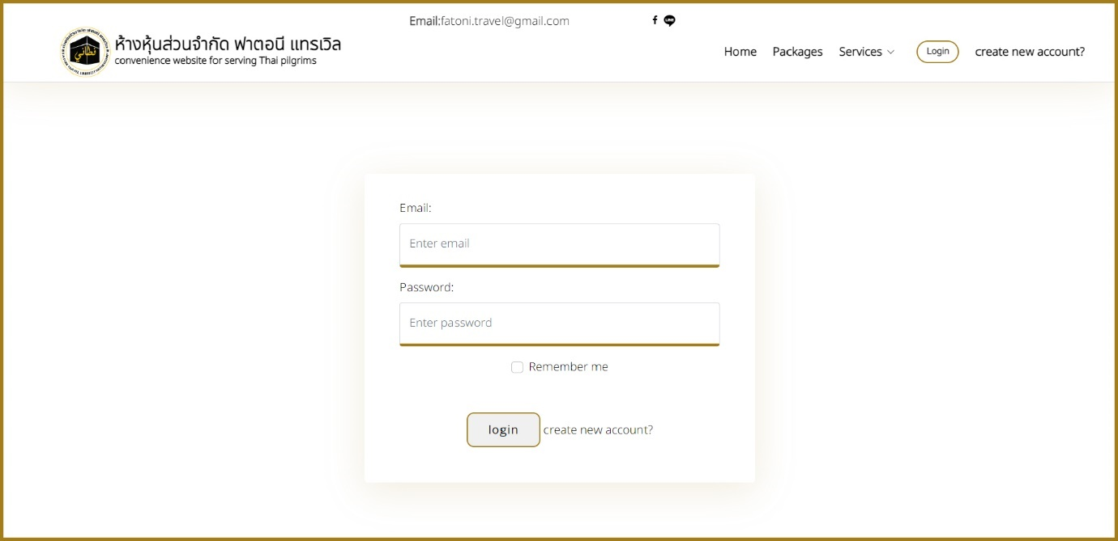User’s Manual

Login page user can login to his account if he already has one through this page by typing his email & password.

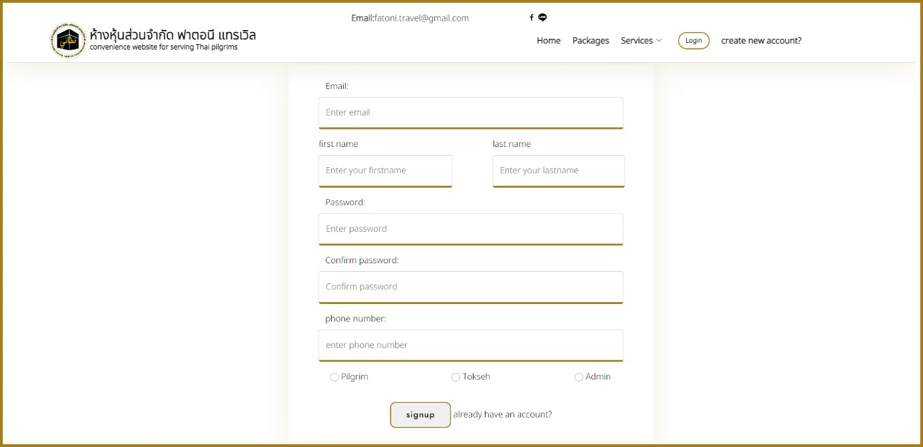

Register page to allow user login into the website system, user can choose which type of user he wants to register

1. Pilgrim
2. Tokseh
3. Admin

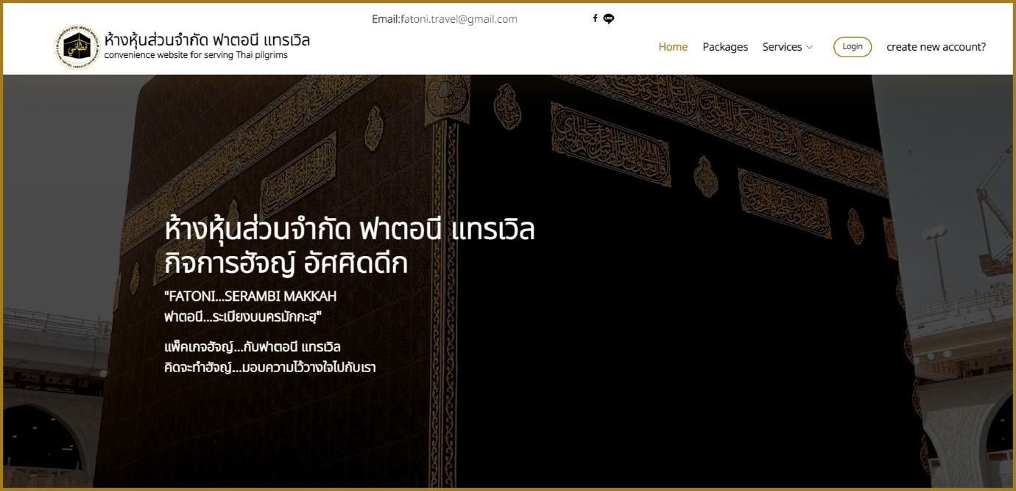

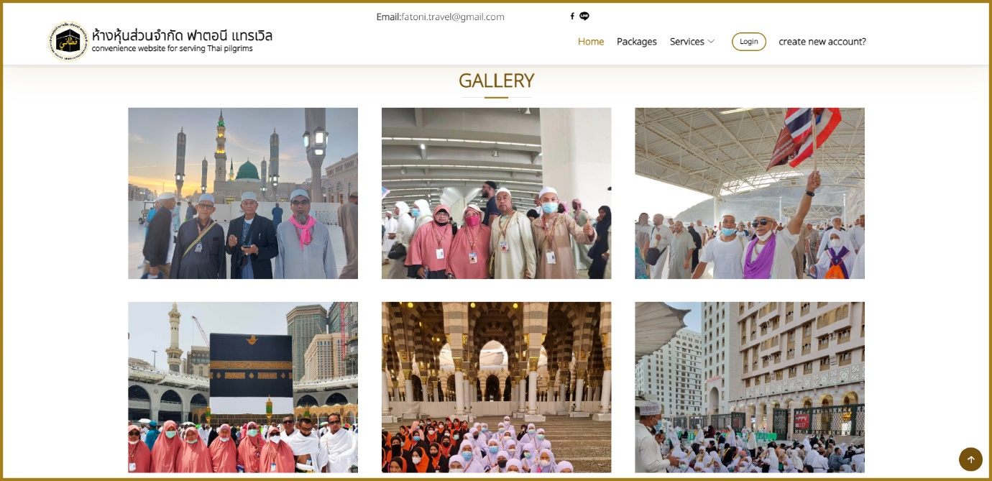This is the form for main page with header including the company logo & name, as well as the contact information above the header, and the menu for the website to help user go from one page to another with ease.

User is not required to register to browse the website, this gallery is showing the previous travels that the company had in the past, the gallery is located in the home page and user can preview it by click on open and the image will open.

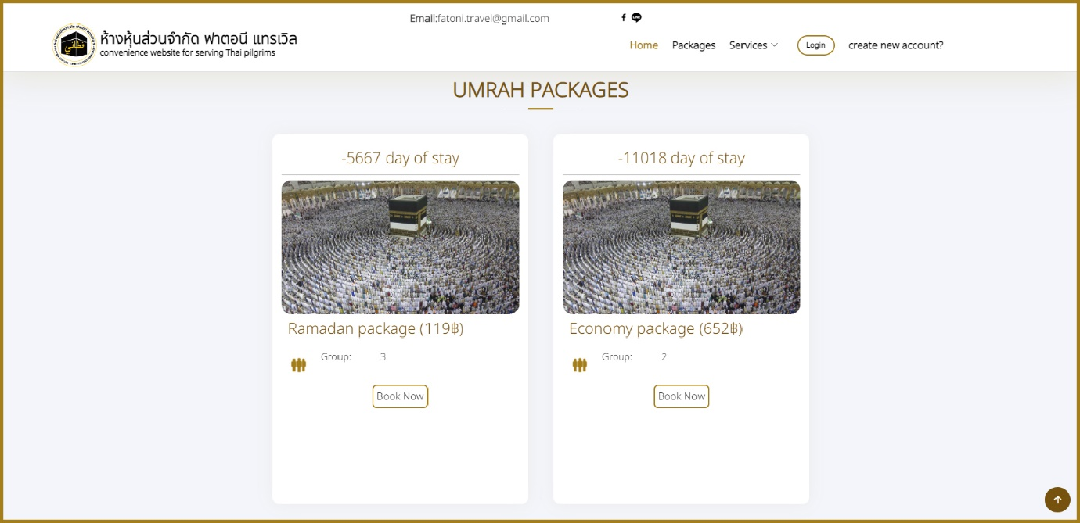

* 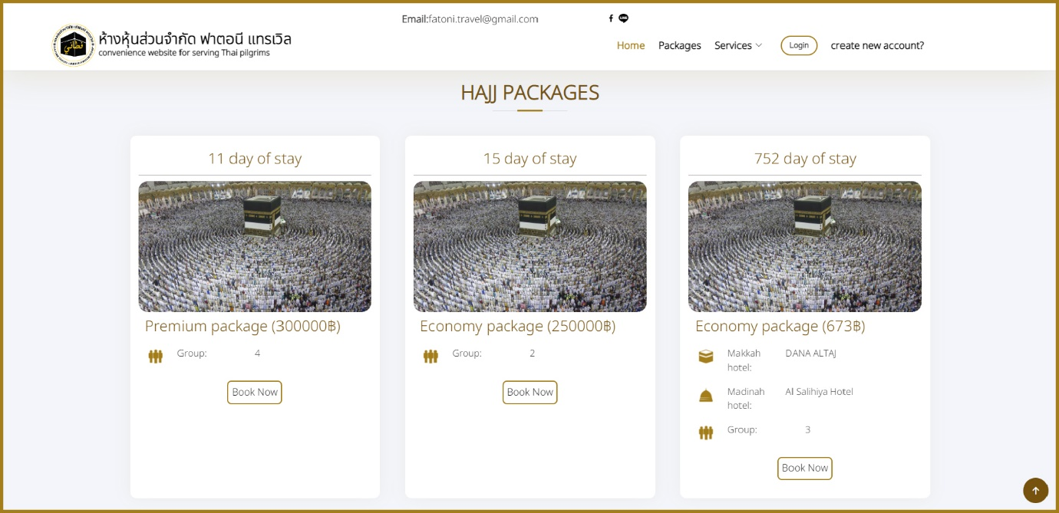Umrah packages
* Hajj packages

The packages section is showing the essential information for packages like the price, how many days will stay, the location, and the capacity.

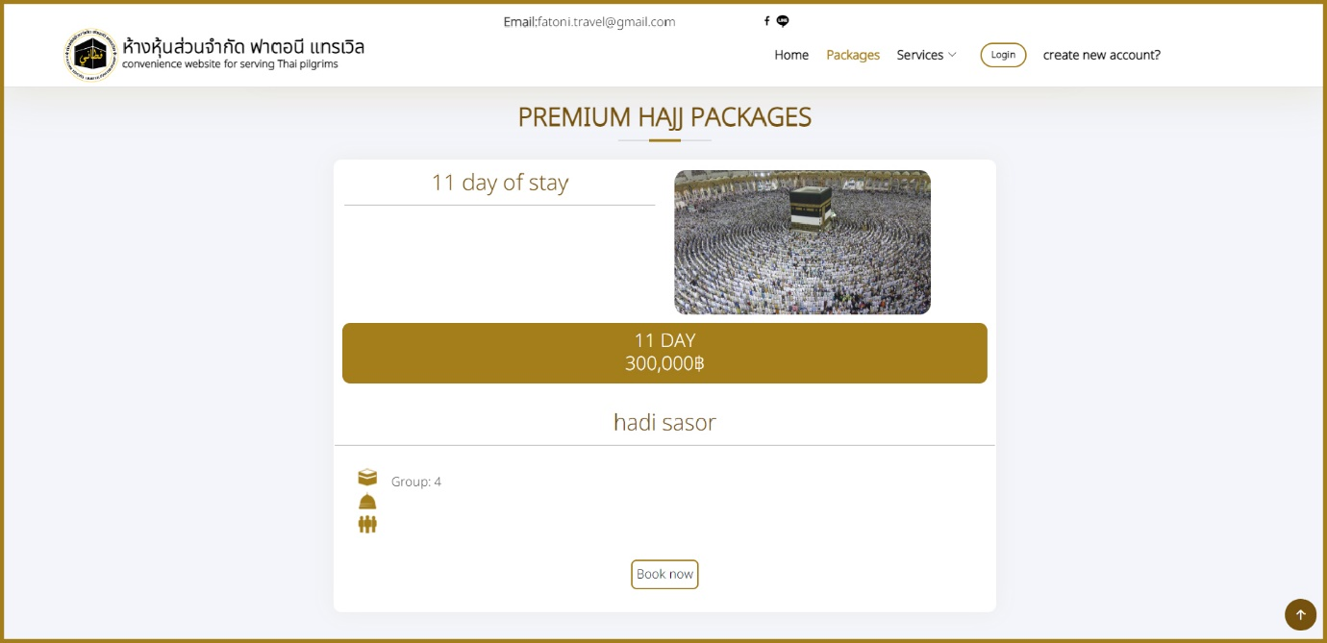

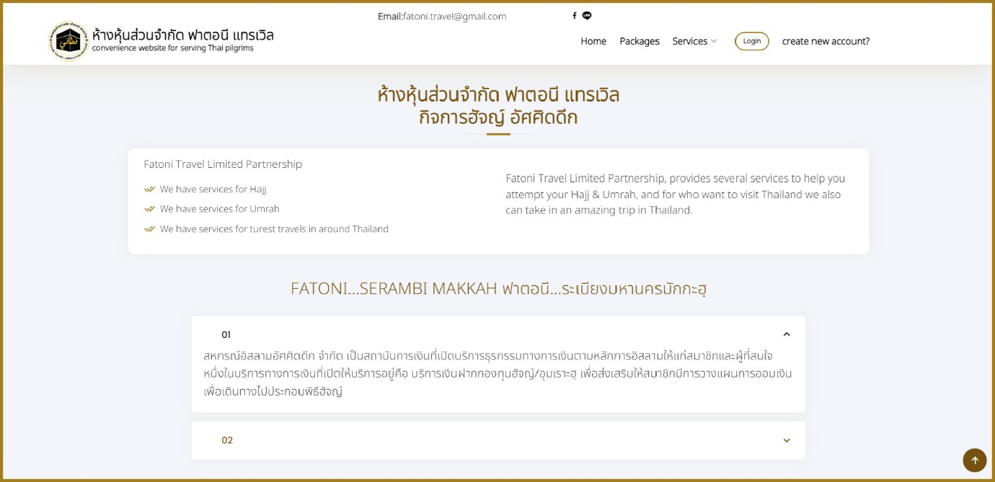This package form is showing more detail about the package to make it easier for the user to know more information about a specific information.

Here is page for more information and details about the company like the employee and partners for the company, explaining services that provided by the company and how they can help the user.

User can find this page in the footer section in

* Information -> About us

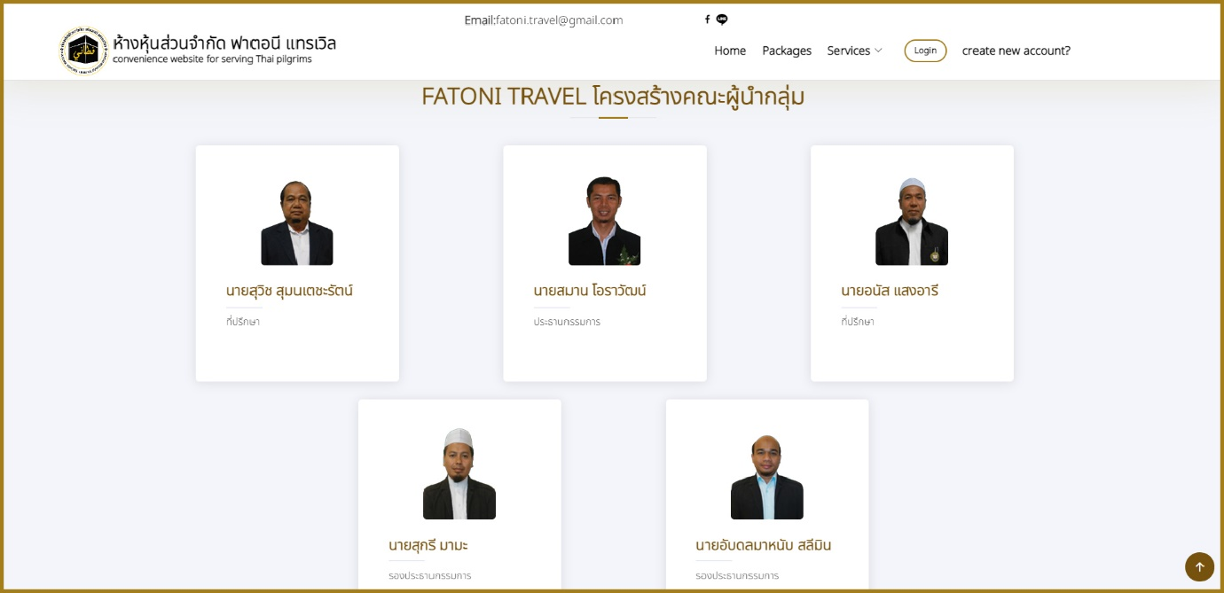

This form in About us page, here user can see the employees name and positions.

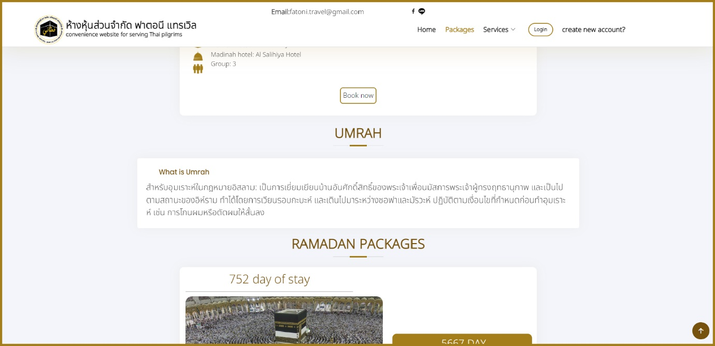

Here you can see knowledge about both Hajj and Umrah what is hajj, why we do hajj, etc.

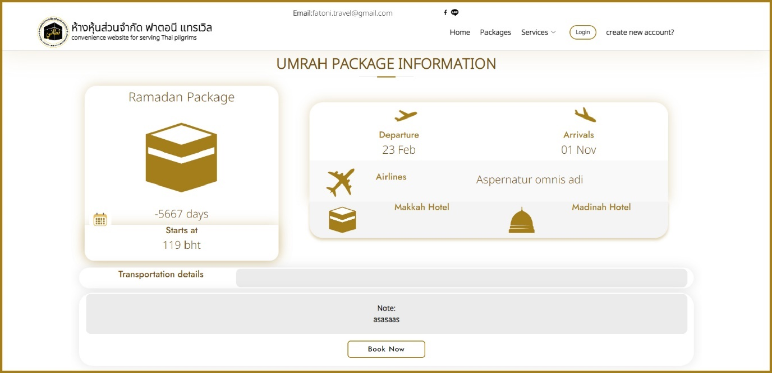

This page is displaying the information about the package when is the flight how many days to stay, the airlines and the price.

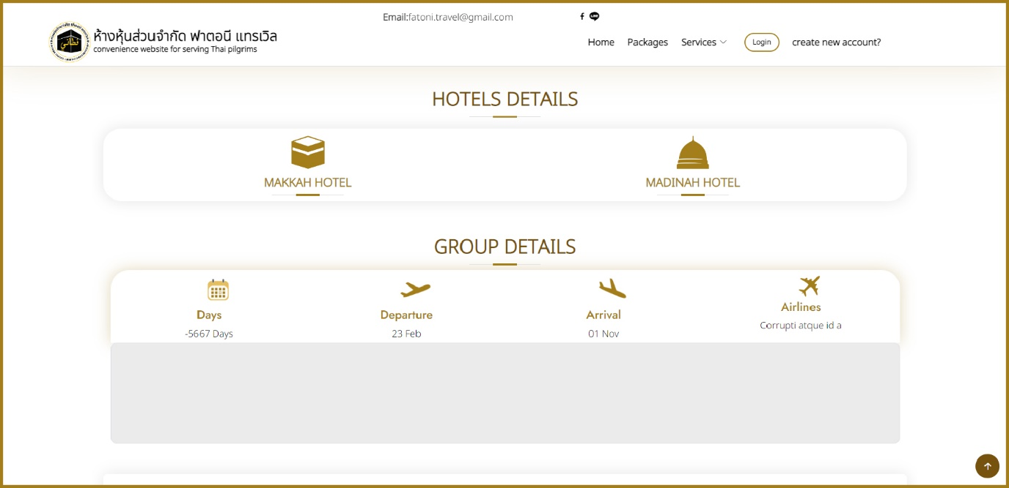

This forms to show hotels details and the information about the group in this flight.

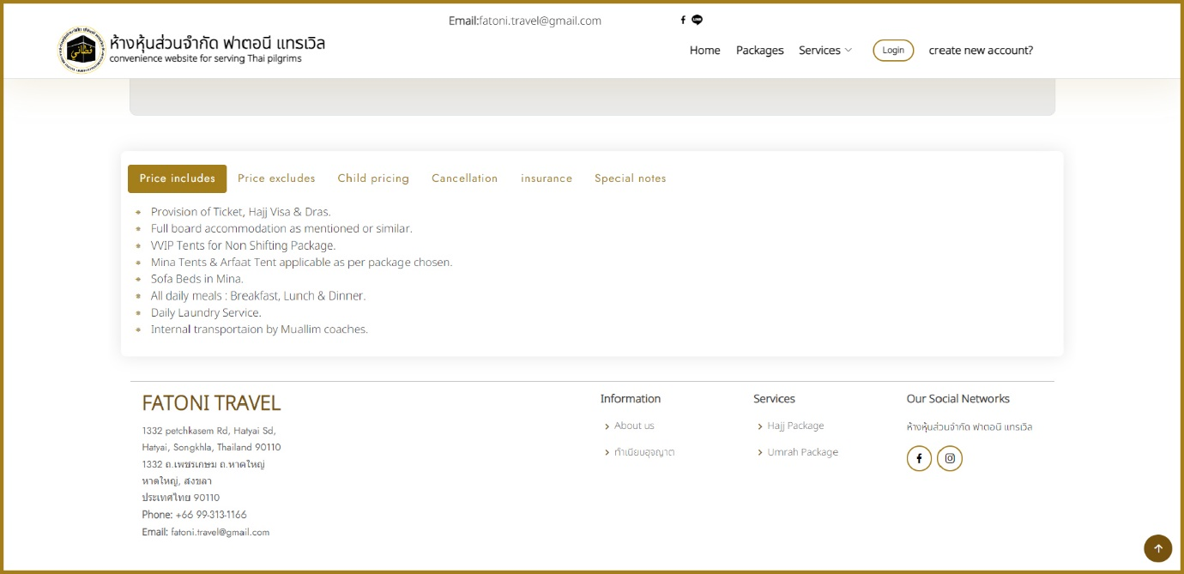

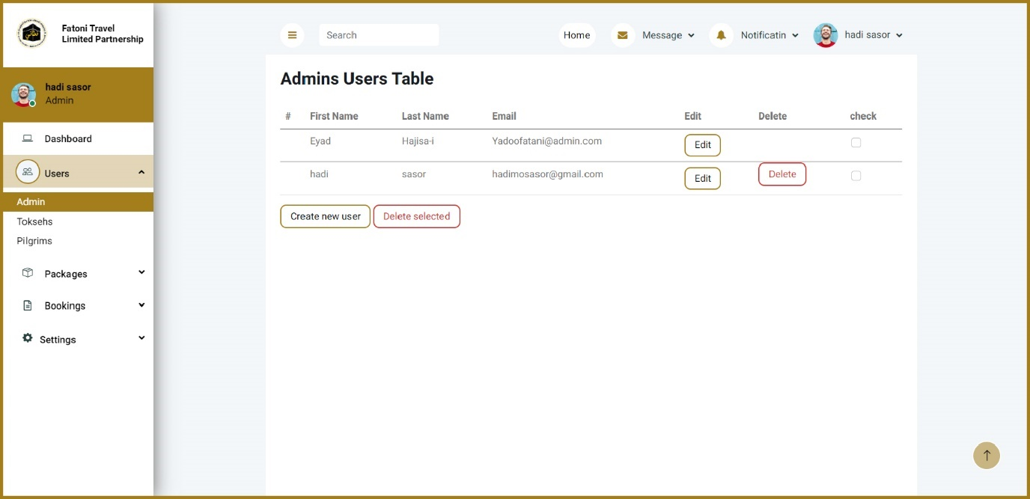Policy information include all detail to ensure that the company is cleared of any unnecessary legal issues, and to clarify the rights of the client and the rights of the company to all competent authorities.

* Dash board

In this page admin can get details about how many admins in this website.

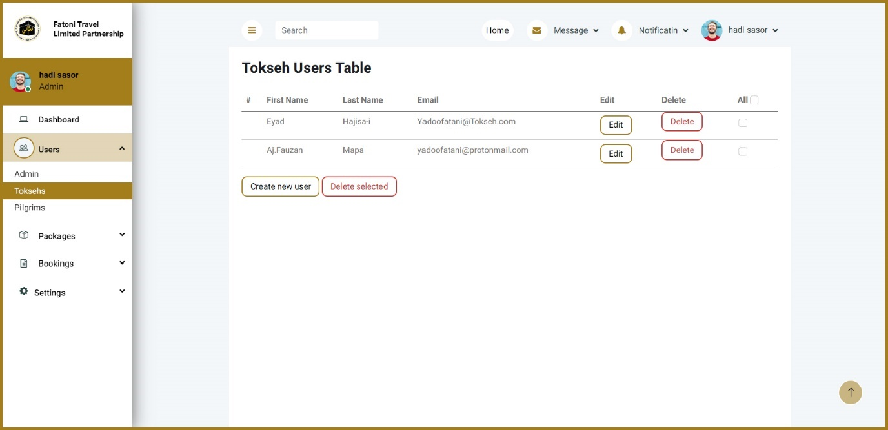

This table show the numbers of tokseh in the website, the admin can edit or delete the tokseh users.

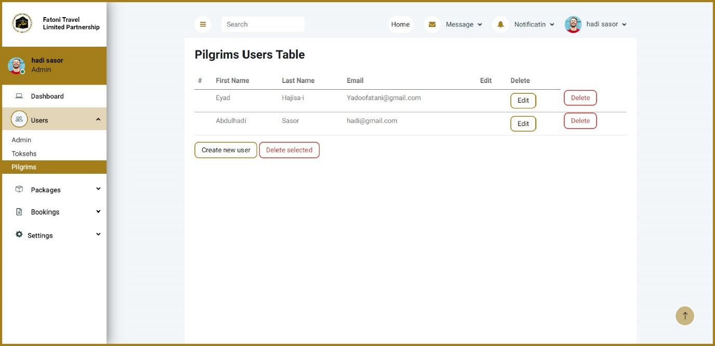

This table show the numbers of pilgrims in the website, the admin can edit or delete the pilgrims’ users.

## Project codes

##### Header codes 1

##### Header codes 2

##### Header codes 3

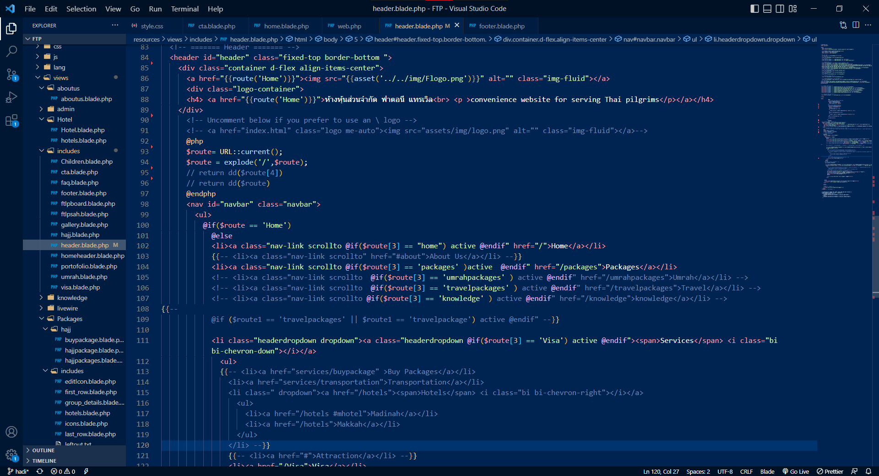

##### Header codes 4

##### Package page codes 1

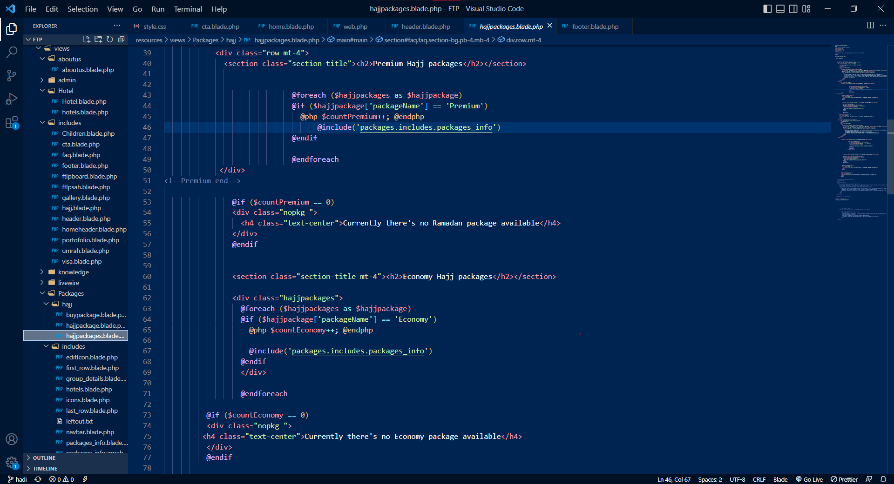

##### Package page codes 2

##### Package page codes 3

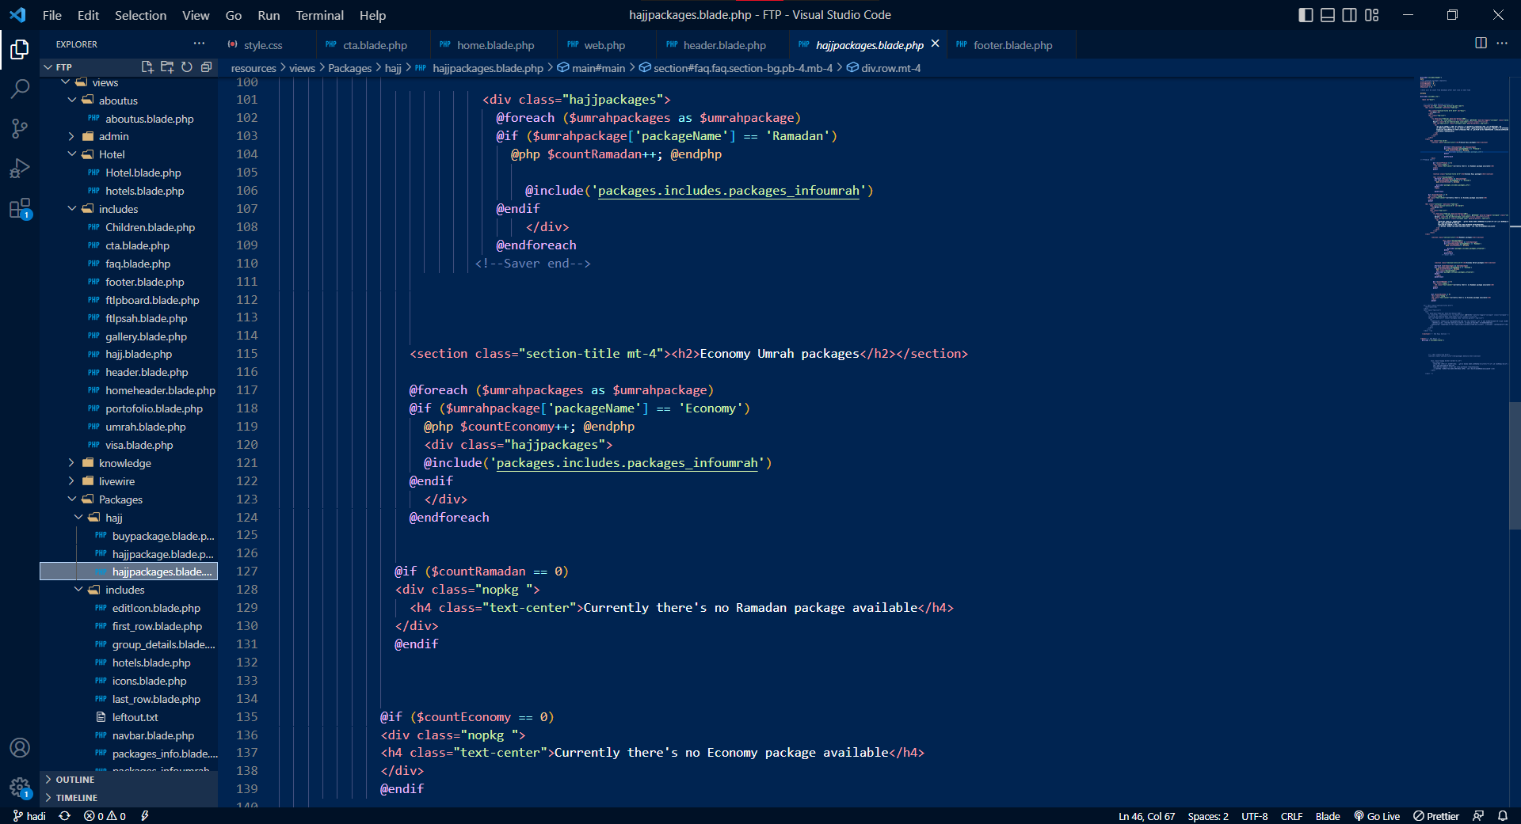

##### Package page codes 4

## suggestions for system improvement

* Can add new category for image.
* Admin can change the images in the website from the admin dashboard.
* Improve to search for a specific item in website.

**Name of the Cooperative Education** Islamic System Corporation's Material Inventory System

**Reporter**  Mr. Abdulhadi sasor

**Faculty** Science and technology

**Program** Fatoni Travel website

……………………………………..

(MR. MAHAMMASHUKRI YISAMA-AE)

**Cooperative education advisor**

THEIS SI COOPERATIVE EDUCATION PROJECT REPORT IS PART OF THE BACHELOR’S DEGREE PROGRAM.

REPORT FOR GATHERING REQUIREMENTS AND ANALYSIS, AND MAKING THE PROCESS OF REVERSE ENGINEERING, DATIL AND SPECIFICATION OF HAJJ AND UMRAH SERVICES WEBSITE APPLICATION.

BECHELOR OF SCINCE INFORMATION TECHNOLOGY, FACULTY OF SCINCE AND TECHNOLOGY OF FATONI UNIVERSITY